Q1 Let P be an EC point. What is the minimum number of EC sums/doubles necessary to compute [259]P?
○ a) 8
○ b) 10
○ c) 11
○ d) 12
○ e) 258
○ f) 259

Q2 What is the main limitation of a trivial secret sharing scheme?
○ a) Unlike the Shamir scheme, it is not ideal
○ b) Unlike the Shamir scheme, it is not unconditionally secure but only computationally secure
○ c) It permits only to implement (t,n) schemes with t strictly lower than n
○ d) It permits only to implement (n,n) schemes and not (t,n) schemes with t<n

Q3 In the Boneh-Franklin’s Identity Based Encryption scheme, what happens if an attacker compromises the PKG?
○ a) Nothing, as there is no PKG in such scheme
○ b) It becomes impossible to decrypt a previously encrypted data
○ c) the attacker may find all private keys for all users
○ d) the attacker may revoke all users’ public keys

Q4 Three parties A, B, C setup a group (3,3) RSA signature, i.e. a message is correctly signed if all three parties contribute to the signature with their shares of the private key d. Being x and y random values (in the appropriate range), shares are:
Share_A = d-x-y
Share_B = x
Share_C = y
Assuming that a message M needs to be signed, schematically describe the specific modular operations and exchange of messages that such a (3,3) RSA signature requires.

Q5 What may happen if Alice digitally signs two different messages M1 and M2,with ECDSA using the same nonce r (r = x-coordinate(kP) mod n)?
○ a) The attacker can compute Alice’s Private key
○ b) The attacker can forge a signature for any linear combination of M1 and M2
○ c) The attacker can decrypt both M1 and M2
○ d) The attacker can perform an expansion attack on one of the two messages

Q6 Assume arithmetic modulus 100. A Linear secret sharing scheme involving 4 parties is described by the following access control matrix:
A: 1 1 1
B: 0 1 0
C: 0 0 1
D: 0 0 -1
Assume that the following shares are revealed:
A → 36
B → 51
D → 18
What is the secret?
a) 3 b) 5 c) 31 d) 33 e) 67 f) 69 g) 95 h) 97 i) another result = __________

Q7 Describe the threshold El Gamal decryption, and specifically explain why the private key is never revealed in the reconstruction.
Q8 A same message M is RSA-encrypted using two different public keys e1 = 11 and e2 = 17, but same RSA modulus n=35. The two resulting ciphertexts are: c1=3 and c2=17. Decrypt the message applying the Common Modulus Attack (show the detailed computations required).
[Just in case you might need to rapidly compute inverses mod 35, see table associated to exercise Q10]
Answer: by the extended GCD(17,11) → {r,s}={2,-3}

Hence

M = 3⁻³ x 17² mod 35 = 12³ x 17² mod 35 = 12

Q9 Consider the Elliptic curve y² = x³ + 2x - 1 defined over the modular integer field Z₅. A) find all the points EC(Z₅) and B) specify what is the order of the corresponding group
O, {0,2}, {0,3}, {2,1},{2,4},{4,1},{4,4}

Order 7

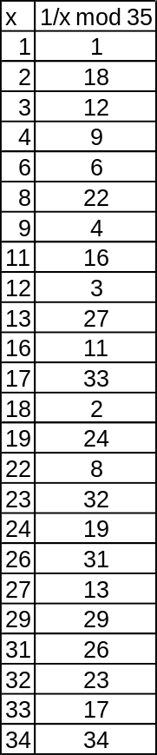
Q10 A Shamir Secret Sharing scheme uses a non-prime modulus p=35 (if you need modular inverses see table on the right). Of the 5 participating parties P₁,…,P₅, with respective x coordinates x_{i} = {1,2,3,4,5}, parties P1, P2 and P5 aim at reconstructing the secret.
a) compute the Lagrange Interpolation coefficients for parties 1,2,5;
b) Reconstruct the secret, assuming that the shares are:
P1 → 18
P2 → 24
P5 → 19
c) Prove that the system is NOT unconditionally secure, by showing that the knowledge of the two shares P1 and P5 leak information about the secret – specifically, after knowing shares P1 and P5 which would be the only possible remaining secret values?

[Answer: Secret = 14;
set of possible secrets: the 7 possible values which satisfy 19+10x mod 35 →
- {4, 9, 14, 19, 24, 29, 34}

